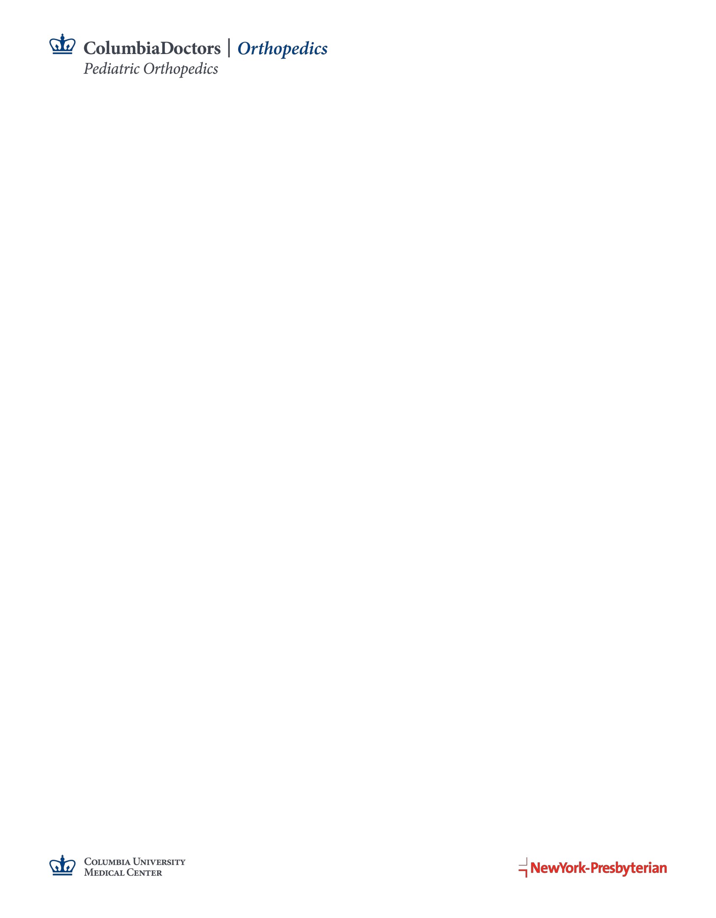

Dear Medical Students:

The Division of Pediatric Orthopedics at Columbia University Medical Center invites 3rd year medical students to apply for The David P. Roye, Jr., MD, Clinical Research Fellowship, a funded one-year clinical research fellowship, starting in the summer of 2023.

This is an exciting opportunity for highly motivated students who are interested in pursuing a career in Orthopedic Surgery. This research position offers training in clinical research and hands-on collaboration with junior and senior faculty research mentors and orthopedic surgeons. You will work closely with 3-4 other members of the research team on a variety of clinical research projects.

Our mission is to improve pediatric musculoskeletal health through evidence based clinical research. As a renowned research center in Pediatric Orthopedics, we have an opportunity to spearhead many initiatives to make significant impacts in this field. Specific areas of interest of our team are:

* + **Clinical Research:** developing new analytical methods for evaluating various surgical and non-surgical techniques and applying these methods to innovate approaches to patient care
  + **Patient-Based Outcome Research:** developing and assessing quality of life and caregiver burden outcome measures reflecting issues of importance to patients and their caregivers
  + **Quality and Safety Research:** investigating and developing methods in improving the quality and safety of the surgical experience for patients and family members, such as preventing surgical site infections post-spine surgery

Every year we have medical students work in our research center between their 3rd and 4th years with great success. Our previous students have matched to their top choice residency programs including Columbia University Medical Center, Harvard University, and Hospital for Special Surgery.

To apply for this position, please email your **CV**, **one letter of recommendation**, **USMLE** **scores** (if available), **unofficial** **transcript**, **brief statement of interest** (limit to one page), and **one writing sample** to Christina Rymond (ccr2141@cumc.columbia.edu).

The deadline for ***priority consideration*** is **Nov. 28, 2022.** The second deadline for submission is **Jan. 31, 2023**. If positions are filled by the first round, the second round may not take place. In addition to the funded fellowship, unfunded research positions may also be available.

Further information about the program can be found here: <https://www.columbiaortho.org/education/medical-students/david-p-roye-jr-md-clinical-research-fellowship>. If you have any questions, please reach out to Christina Rymond (ccr2141@cumc.columbia.edu).

Sincerely,

**Michael G. Vitale, MD, MPH**

*Ana Lucia Professor of Pediatric Orthopedic Surgery and Neurosurgery*

*Vice Chair, Quality and Strategy*

*Director, Division of Pediatric Orthopaedics*

*Chief, Pediatric Spine and Scoliosis Service*

Columbia University Medical Center

Morgan Stanley Children’s Hospital of New York - Presbyterian